Deploying using App Service
- Tutorial about that: https://www.youtube.com/watch?v=FOTTt-qTv9o&list=PLLasX02E8BPADO_R-D6ctSoV4EeE8ow9B&index=7
- If deployment fails it might be worth to try again in some time or try lower version of Azure Resources extension in VS code (version v0.8.0)
- I can check web app files in VS code:
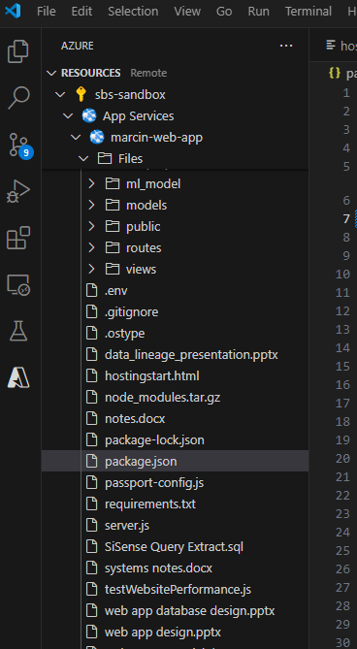

- I can view files and use server consol in Kudu. I can access it in the Development Tools > Advanced Tools section:
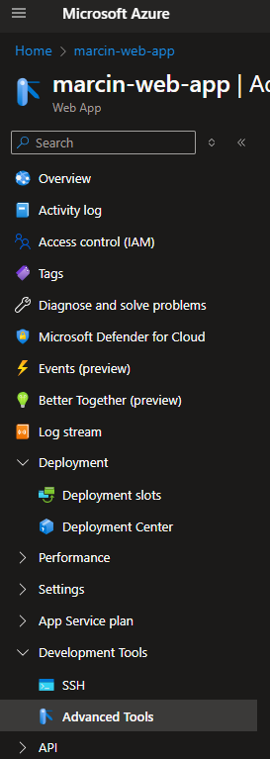

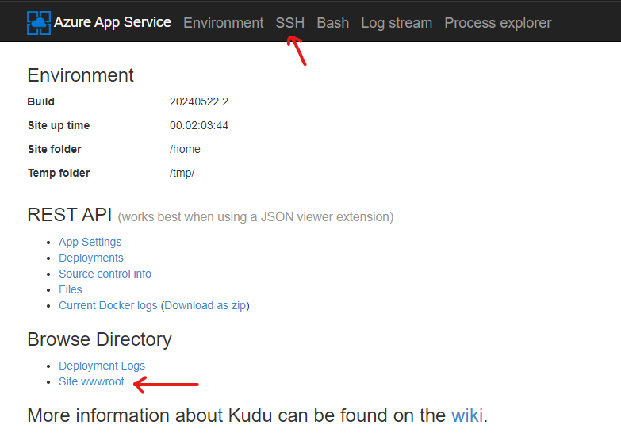

In order to use SSH console I need to set up the ‘Always on’ setting to ‘On’:
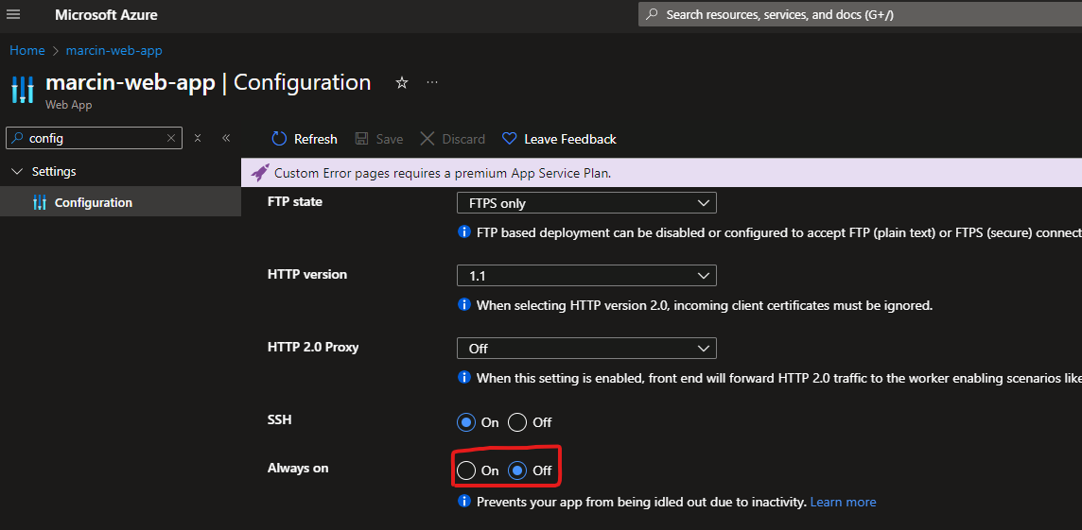

- I can check logs in the ‘Diagnose and solve problems’ section of App Service:
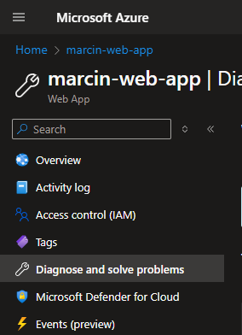

in the Monitoring > Logs section (there is a tab called ‘Queries’ with different useful queries for checking logs):
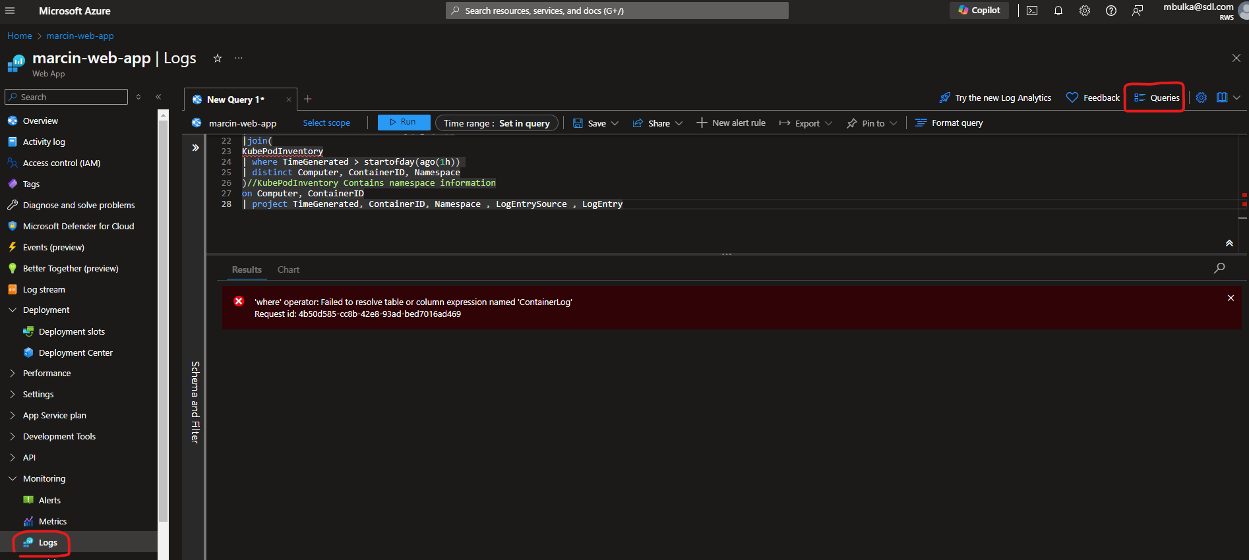

And in the Log Stream section:
